***Resume***



***Of***

***MD. Shahid Miah***

***Tigor ,Sarail ,Brahmanbaria***

***Carrier Objective***

Willing to work in position with sincerity , Responsibility ,strong follow up , Energetic.

I will be Attentive for better understanding and positive attitude to make proper decision for problem solving*.*

***Communication Address:***

***Permanent Address :village -Tighor P.O-Sarail ,Tana- Sarail***

***District –Brahmanbaria***

***Present Address : Village –Tighor P.O-Sarail ,Tana- Sarail***

***District –Brahmanbaria***

***Academic DetailS***

***\*Secondary School Certificate.***

*Institute Name : Sarail Annoda Gov’t School.*

*Passing year :2013*

*Group : Business Studies*

*Result :GPA 3.94 out of 5.00*

*Board :Comilla*

***\*Higher Secondary certificate***

*Institute Name: Sarail Degree College*

*Passing Year : 2015*

*Group : Business Studies.*

*Result : GPA 3.42 Out Of 5.00*

*Board : Comilla*

*Bachelor of Business Administration (BBA) 4th year running*

*Subjects - Accounting.*

***Computer***

Operating System : Windows 7,windows 8,windows 10

Work skill :SEO, Graphic design and motion Graphic ,wordpress etc

Software skill : Adobe photoshop cc, Adobe illustrator cc, Adobe indesign, Adobe after effects, Adobe premire pro, Camtasia 9,

Work experience : Freelancer at upwork

**Upwork** **profile** **link** :

Protflolio website-

Web site :http://www.freelancer-shahid.com

Typing Spee : Bangla 35 And English 35

***Personal Details***

Fathers Name : Md Abu Bakker

Mothers Name : Sumsunnaher

Permanent Address : Village- Tighor, P.O-Sarail , Tana- Sarail

District –Brahmanbaria.

Present Address : Village –Tighor, P.O-Sarail ,Tana- Sarail

District –Brahmanbaria

Nationality : Bangladeshi by birth

Religion : Islam.

Height : 5 Feet 3 Inchi

Marital Status : Unmarried.

Date of Birth : 15/03/1998

Hobbies : Cricket , Badminton and tarveling.

Reference by : Mahbub Hosen Mamun

Phone Number : 01671144031

***Declaration***

I, hereby, declare that the information stated is Correct to the best of my Concern.

Sinature:

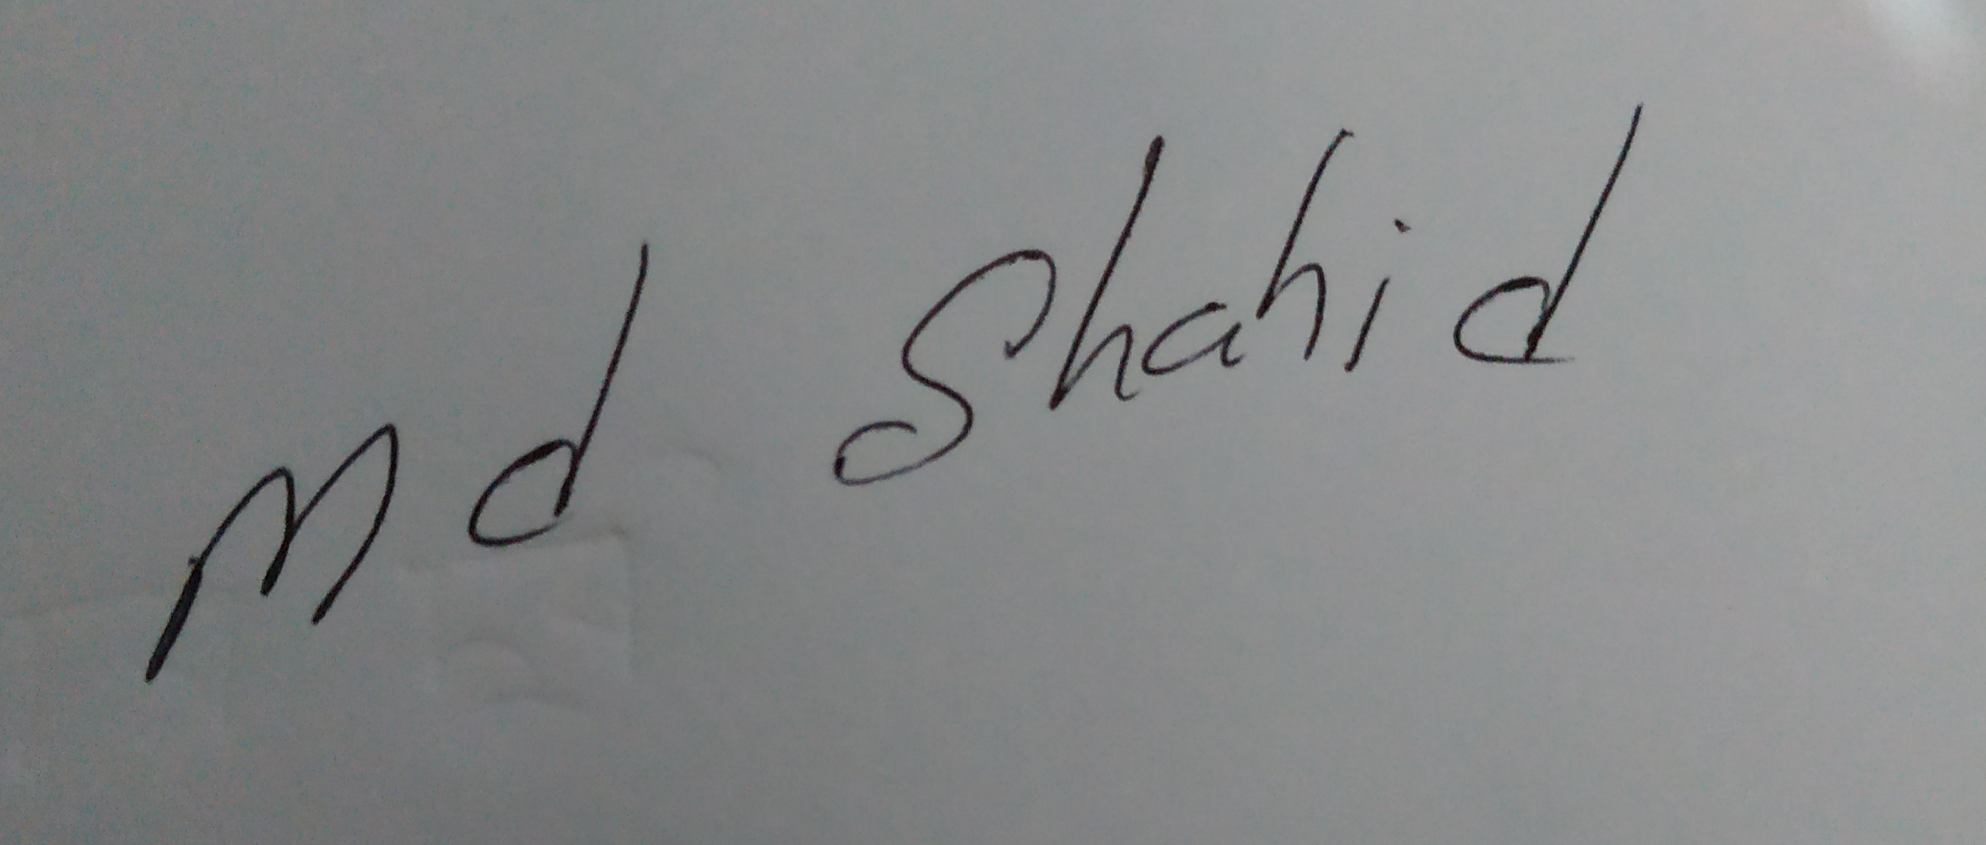

Date:30/12/2019